AERO1005 MATLAB Coursework 2

Author: Add your name
Student ID: Put your ID number here
Date of report: Add submission date here

For questions which require you to write text (i.e., descriptive sentences), or include images and graphs, please add them to the Word submission template.
Task1
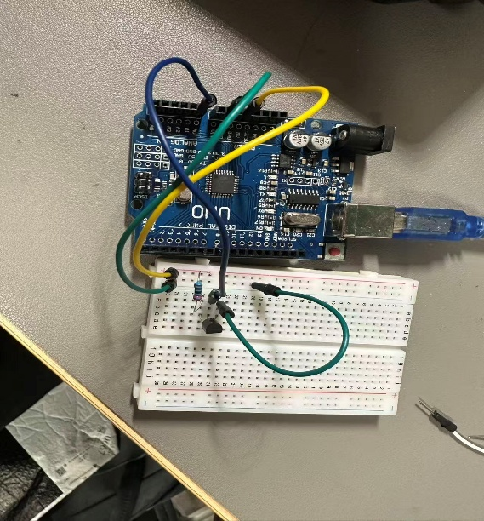
Task2
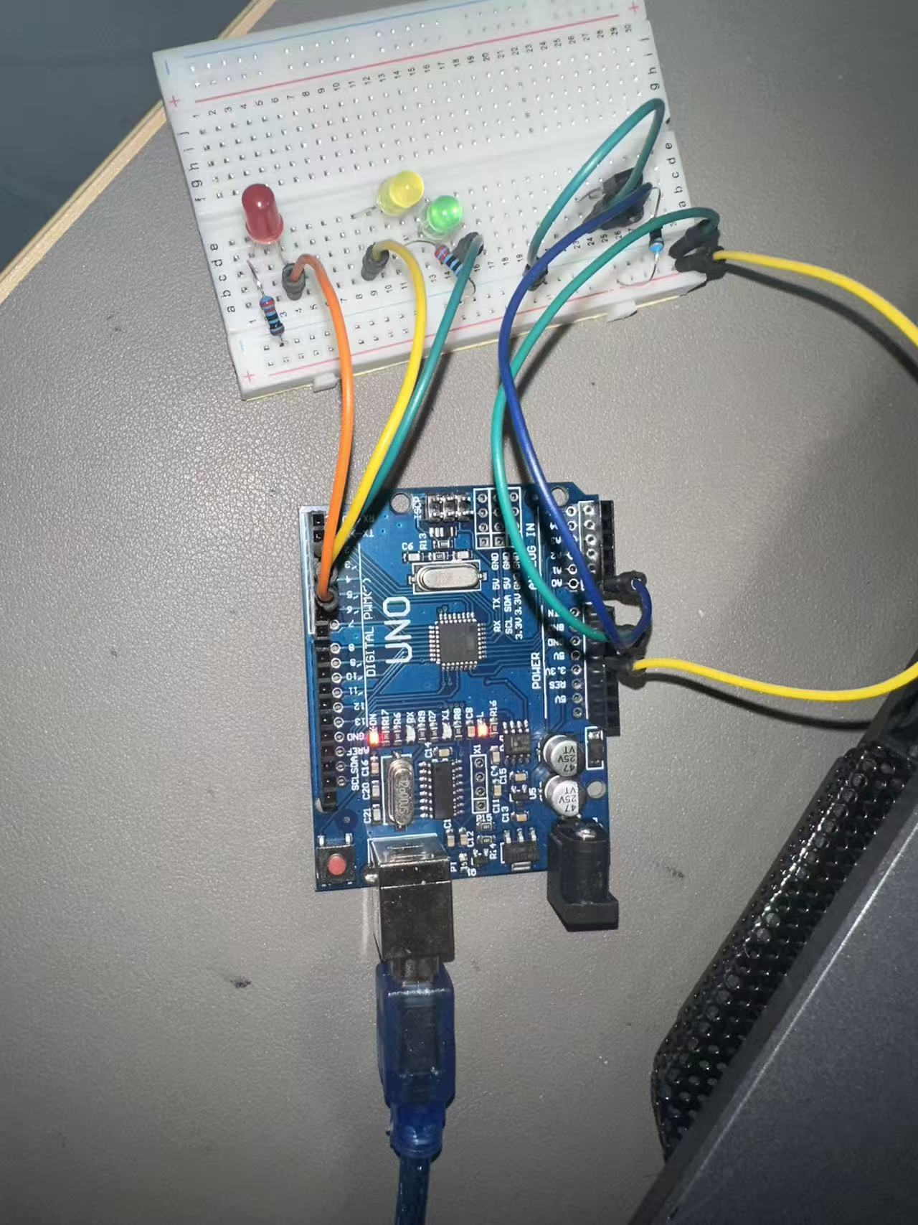

Task3
Reflective Statement
Challenges:
The most significant challenge in this project was implementing the non-blocking infinite loop for Task 2. Initially, using the pause() command to control the LED blinking sequence caused the entire program to halt, delaying the temperature sampling interval and freezing the live graph. Another challenge emerged in Task 3, where raw temperature differentials between consecutive seconds were too erratic due to analog sensor noise, causing the LEDs to trigger incorrectly.
Strengths:
To overcome the blocking issue, a robust non-blocking timer was successfully developed using MATLAB's tic and toc functions. By applying the modulo operation (mod) to the elapsed time, the LEDs could blink asynchronously without interrupting the 1-second temperature sampling. Additionally, to address the sensor noise in Task 3, a 10-second sliding window algorithm was implemented. This successfully smoothed the data, allowing for accurate and stable calculation of the temperature derivative (rate of change) and reliable 5-minute predictions.
Limitations:
The prediction algorithm assumes that the rate of temperature change remains strictly linear and constant over a 5-minute period. In real thermodynamic systems, temperature changes often follow exponential or logarithmic curves, meaning the current linear extrapolation could overestimate the final temperature. Furthermore, the MCP9700A analog thermistor has inherent electrical noise, limiting the ultimate precision of the readings compared to digital counterparts.
Suggested Future Improvements:
For future iterations, replacing the analog thermistor with a high-precision digital sensor (such as the DS18B20) would significantly reduce signal noise. Moreover, instead of a simple linear extrapolation, advanced algorithms like a Kalman Filter or exponential smoothing could be introduced to predict future temperatures more accurately. Finally, implementing a PID (Proportional-Integral-Derivative) controller algorithm in the code would allow the system to actively regulate a cooling/heating mechanism, rather than simply triggering passive visual alarms.

